**eg:Query the information of students.**

select * from student;

**Q1: Query the information and course scores of students whose grades in the "01" course are higher than those in the "02" course**

SELECT s.s_id, s.s_name, s.s_brith, s.s_sex,

c1.c_name AS course_01,

c2.c_name AS course_02,

sc1.s_score AS score_01,

sc2.s_score AS score_02

FROM student s

JOIN

score sc1 ON s.s_id = sc1.s_id

JOIN

score sc2 ON s.s_id = sc2.s_id

JOIN

course c1 ON sc1.c_id = c1.c_id

JOIN

course c2 ON sc2.c_id = c2.c_id

WHERE

c1.c_id = '01' AND c2.c_id = '02' AND sc1.s_score > sc2.s_score;

**Q2:** **Query the information and course scores of students whose grades in the "01" course are lower than those in the "02" course**

SELECT s.s_id, s.s_name, s.s_brith, s.s_sex,

c1.c_name AS course_01,

c2.c_name AS course_02,

sc1.s_score AS score_01,

sc2.s_score AS score_02

FROM student s

JOIN

score sc1 ON s.s_id = sc1.s_id

JOIN

score sc2 ON s.s_id = sc2.s_id

JOIN

course c1 ON sc1.c_id = c1.c_id

JOIN

course c2 ON sc2.c_id = c2.c_id

WHERE

c1.c_id = '01' AND c2.c_id = '02' AND sc1.s_score < sc2.s_score;

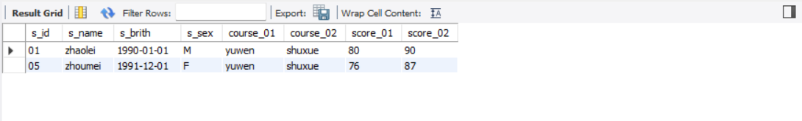

**Q3:** **Query the student number, student name and average score of students whose average score is greater than or equal to 60 points**

SELECT s.s_id, s.s_name, AVG(sc.s_score) AS average_score

FROM student s

JOIN

score sc ON s.s_id = sc.s_id

GROUP BY

s.s_id, s.s_name

HAVING

AVG(sc.s_score) >= 60;

**Q4: Query the student number, name and average score of students whose average score is less than 60 points (including those with and without scores)**

SELECT

s.s_id,

s.s_name,

IFNULL(AVG(sc.s_score), 0) AS average_score

FROM student s

LEFT JOIN

score sc ON s.s_id = sc.s_id

GROUP BY

s.s_id, s.s_name

HAVING

IFNULL(AVG(sc.s_score), 0) < 60;

**Q5: Query the student number, student name, total number of courses selected, and total grades of all courses (including those without selected courses) of all students**

SELECT s.s_id, s.s_name, COUNT(DISTINCT sc.c_id) AS total_courses, SUM(IFNULL(sc.s_score, 0)) AS total_score

FROM student s

LEFT JOIN score sc ON s.s_id = sc.s_id

GROUP BY s.s_id, s.s_name;

**Q6: Query the number of teachers with the surname "Li"**

SELECT COUNT(*) FROM teacher

WHERE t_name LIKE 'li%'

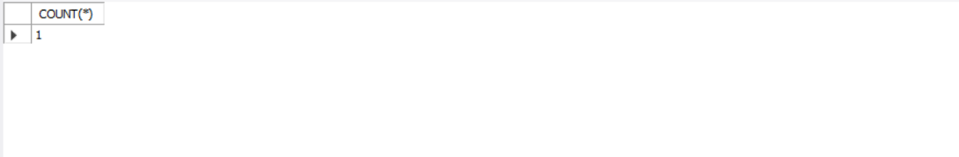

**Q7: Query the information of students who have studied with teacher "zhangsan"**

SELECT s.s_id, s.s_name

FROM student s

WHERE s.s_id IN (

SELECT DISTINCT sc.s_id

FROM score sc

JOIN course c ON sc.c_id = c.c_id

JOIN teacher t ON c.t_id = t.t_id

WHERE t.t_name = 'zhangsan'

);

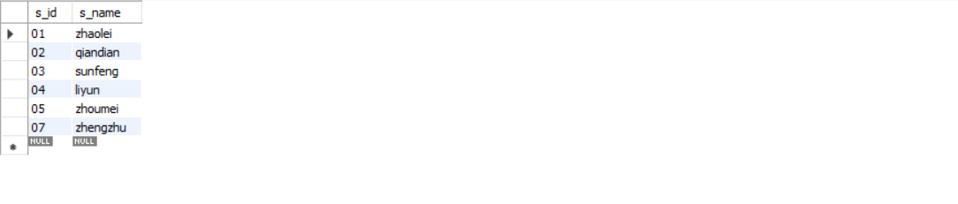

**Q8: Query the information of students who have not studied under teacher "zhangsan"**

SELECT s.s_id, s.s_name

FROM student s

WHERE s.s_id NOT IN (

SELECT DISTINCT sc.s_id

FROM score sc

JOIN course c ON sc.c_id = c.c_id

JOIN teacher t ON c.t_id = t.t_id

WHERE t.t_name = 'zhangsan'

);

**Q9: Query the information of students who have studied the course numbered "01" and also studied the course numbered "02"**

SELECT DISTINCT s.*

FROM

student s

WHERE s.s_id IN (

SELECT s_id FROM score WHERE c_id = '01'

) AND

s.s_id IN (

SELECT s_id FROM score WHERE c_id = '02'

);

**Q10: Query the information of students who have studied the course numbered "01" but not the course numbered "02"**

SELECT DISTINCT s.*

FROM student s

WHERE s.s_id IN (

SELECT s_id FROM score WHERE c_id = '01'

) AND

s.s_id NOT IN (

SELECT s_id FROM score WHERE c_id = '02'

);

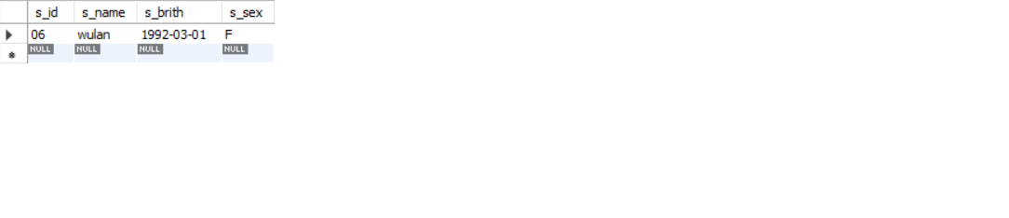

**Q11: Query information about students who have not completed all courses**

SELECT st.*

FROM student st

WHERE (SELECT COUNT(DISTINCT c_id) FROM course) >

(SELECT COUNT(DISTINCT c_id) FROM score WHERE s_id = st.s_id);

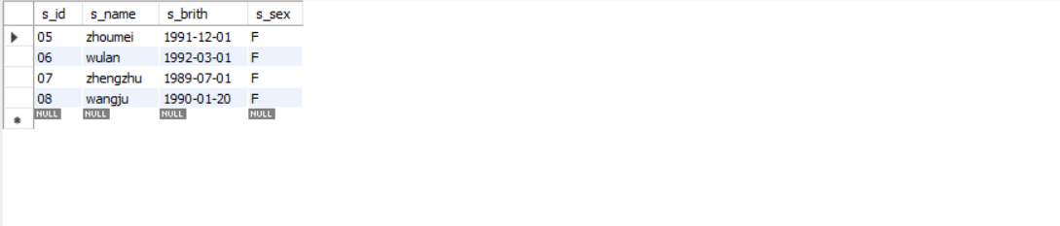

**Q12: Query the information of students who have at least one course that is the same as the student with student number "01"**

SELECT DISTINCT s.*

FROM

student s

JOIN

score sc ON s.s_id = sc.s_id

WHERE

sc.c_id IN (SELECT c_id FROM score WHERE s_id = '01') AND s.s_id NOT LIKE "01";

**Q13: Query the information of other students who are studying the same course as the student numbered "01"**

SELECT DISTINCT s.*

FROM student s

JOIN

score sc ON s.s_id = sc.s_id

WHERE

sc.c_id IN (SELECT c_id FROM score WHERE s_id = '01') AND s.s_id NOT LIKE '01';

**Q14: Query the names of students who have not studied any course taught by "zhangsan"**

SELECT DISTINCT s.s_name

FROM student s

WHERE

s.s_id NOT IN (

SELECT s_id

FROM score

JOIN course ON score.c_id = course.c_id

WHERE course.t_id = (

SELECT t_id

FROM teacher

WHERE t_name = 'zhangsan'

)

);

**Q15: Query the student ID number, name and average grade of students who failed two or more courses (Even if you did not take the exam, your score will be recorded as zero, so it should be considered a failure.)**

SELECT s.s_id, s.s_name, IFNULL(AVG(sc.s_score), 0) AS average_grade

FROM student s

LEFT JOIN

score sc ON s.s_id = sc.s_id

GROUP BY

s.s_id, s.s_name

HAVING

SUM(IFNULL(sc.s_score, 0) < 60) >= 2;

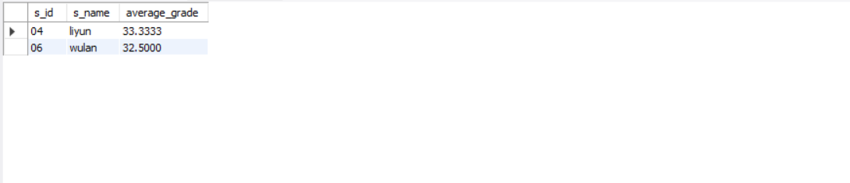

**Q16: Query the student information of "01" course whose score is less than 60 and sorted by score in descending order**

SELECT s.s_id, s.s_name, sc.s_score

FROM student s

JOIN

score sc ON s.s_id = sc.s_id

WHERE

sc.c_id = '01' AND

sc.s_score < 60

ORDER BY

sc.s_score DESC;

**Q17: Displays the grades for all students in all courses and the average grade by average grade from highest to lowest (Students who did not take the exam will have a score of 0)**

SELECT s.s_id, s.s_name, c.c_id, c.c_name, IFNULL(sc.s_score, 0) AS s_score, IFNULL((SELECT AVG(s_score) FROM score WHERE s_id = s.s_id), 0) AS average_grade

FROM student s

CROSS JOIN

course c

LEFT JOIN

score sc ON s.s_id = sc.s_id AND c.c_id = sc.c_id

ORDER BY

average_grade DESC;

**Q18: Query the highest score, lowest score and average score of each subject: displayed in the following form: course ID, course name, highest score, lowest score, average score, passing rate, medium rate, good rate, excellent rate – passing is >=60 , medium is: 70-80, good is: 80-90, excellent is: >=90**

SELECT c.c_id, c.c_name,

MAX(sc.s_score) AS highest_score,

MIN(sc.s_score) AS lowest_score,

AVG(sc.s_score) AS average_score,

AVG(CASE WHEN sc.s_score >= 60 THEN 1 ELSE 0 END) * 100 AS passing_rate,

AVG(CASE WHEN sc.s_score BETWEEN 70 AND 79.99 THEN 1 ELSE 0 END) * 100 AS medium_rate,

AVG(CASE WHEN sc.s_score BETWEEN 80 AND 89.99 THEN 1 ELSE 0 END) * 100 AS good_rate,

AVG(CASE WHEN sc.s_score >= 90 THEN 1 ELSE 0 END) * 100 AS excellent_rate

FROM course c

LEFT JOIN

score sc ON c.c_id = sc.c_id

GROUP BY

c.c_id, c.c_name;

**Q19: Query the student information, Sort by the scores of each subject and display the ranking**

SELECT s.s_id, s.s_name, sc.c_id, sc.s_score,

(

SELECT COUNT(DISTINCT sc2.s_id) + 1

FROM score sc2

WHERE sc2.c_id = sc.c_id AND sc2.s_score > sc.s_score

) AS ranking

FROM student s

JOIN

score sc ON s.s_id = sc.s_id

ORDER BY

sc.c_id, sc.s_score DESC;

**Q20: Query students’ total scores and rank them**

SELECT s.s_id, s.s_name,

SUM(sc.s_score) AS total_score,

RANK() OVER (ORDER BY SUM(sc.s_score) DESC) AS ranking

FROM student s

LEFT JOIN

score sc ON s.s_id = sc.s_id

GROUP BY

s.s_id, s.s_name

ORDER BY

total_score DESC;

